MYSTERIOUSLY LIMITED NARRATIVE POSSIBILITIES FOR WOMEN IN *SPIDER-WOMAN*

Lore Whittemore

MDST 7051: Qualitative Research Methods for Media

February 16, 2023

*Spider-Woman,* an animated cartoon television series that aired on ABC-TV from September 22nd, 1979, until March 1st, 1980, featured Jessica Drew as the titular Spider-Woman and became first animated Marvel series to feature a woman as the protagonist.[1] Despite this historic claim, documents previously in the possession of the show’s creator and executive producer Stan Lee indicate gender dynamics within *Spider-Woman* underwent significant revisions from the show’s initial conception to the animated, produced version that aired. A character overview and two different drafts of a generalized treatment outlining the show reveal decisions made in the development phase limited the narrative possibilities for women within the animated and aired episodes of *Spider-Woman*.

A brief, one-page list of characters preserves the cast of supporting characters as they were conceived early in the developmental process; its placement within the developmental timeline is inferred based upon the information that the character summary sheet was printed with the phrase “Expose Mag.” as opposed to “Justice,” a change reaffirmed by other preproduction documents as early as October 1978.[2] This summary provides an brief overview of the proposed cast of characters: Jessica Drew as Spider-Woman, Jerry Hunt as a U.S. government agent, Benjamin Alley as a newspaper editor, Penny as “J’s niece,” Alice as “J’s stout, motherly maid,” and Police Chief Clarence Cooper who hates Spider-Woman (Figure 1). Of the six human characters conceptualized at this stage, half of them were women.

These character dynamics are elaborated upon in an undated, photocopied treatment describing the premise of “The Mysterious Spider-Woman,” and this treatment provides a preview of the possibilities of interactions women could have with each other. The two female characters in the supporting cast are discussed in more detail, including “a cute, bright little 12-year-old girl named Penny Baker [emphasis in original]. An orphan, Penny lives with her Aunt Jessica [… and Penny] wants to grow up just like her [Spider-Woman],” and a “warm, motherly maid named Alice. [emphasis in original …] She half-suspects Spider-Woman must be a man, because no female could possibly do all the things Spider-Woman gets the credit for accomplishing” (Figure 2).[3] This treatment alludes to potential for multifaceted relationships and interactions between female characters; Penny admires Spider-Woman to the extent that she wishes her aunt was more like her, and Alice cares for Jessica, even if she disavows Spider-Woman.

However, a different version of a nearly identical treatment that combines printed text with handwritten notes, ideas, and revisions redefines narrative possibilities for female interactions in *Spider-Woman.* The base typed text in this version of the document includes references to “Expose” magazine and not the later “Justice” publication, suggesting the printed text predates the version discussed above, which used the term “Justice”—but handwritten notes annotating this printed draft provide insight into intentional character alterations that were replicated in later documents, many of which were also maintained throughout the production and release of *Spider-Woman*. In the paragraph detailing the character Penny Baker, every instance of “Penny” was struck and replaced with “Billy”; the “she” and “her” pronouns were replaced with “he” and “his.”[4] Only one additional change was made to the character: instead of Penny wanting to grow up just like Spider-Woman, Billy “wants to be her partner she he grows up”—noting the gendered limitations of aspiring to be like a heroine (Figure 3). The character of Alice is subjected to an even more drastic change. While the printed draft acknowledged the character as Jessica’s “motherly maid, Alice,” these three words are struck through; handwritten instead is “loyal Zorbo” (Figure 4). The character of Zorbo did not exist in the previous iteration, but notes on earlier pages in this handwritten revision reveal Zorbo to be conceived as the “faithful assistant” of Jessica’s father. There seems to be much contention about this character; the introduction of Zorbo is crossed out and replaced with the name “Rabu,” which is then rewritten again as “Rammu” (Figure 5). Eventually, paragraphs about Alice and mentions of Zorbo/Rabu/Rammu are struck through; no version of the character is included in the produced episodes of *Spider-Woman.* Throughout this revised draft, both supporting female characters are replaced with male characters before one is rejected entirely, forcing Jessica into the role as the only woman prominent within the show. These changes were finalized and ultimately represented within the episodes that aired, which limited the narrative’s possibilities to what it could accomplish with characters of Jessica Drew, Billy, and Jeffrey “Jeff” Hunt, an amalgamation of the earlier characters Jerry Hunt and Benjamin Alley.

Although *Spider-Woman* undoubtedly made progress towards the representation of women as protagonists within Marvel media, it failed due to a lack of male viewership, which prompted Stan Lee to write a letter to ABC-TV advocating for the character of Jeff to become Brute-Man, a superheroic male counterpart to Jessica Drew’s Spider-Woman,in hopes of saving the show.[5] Unfortunately, this situation remains interrelated with discussions still being had about gender equality within the Marvel Cinematic Universe today. An April 2019 survey that considered public opinion about whether there should be more woman-led superhero movies noted that only 31% of 2205 respondents thought there should be; notably, the Marvel Cinematic Universe had released their first woman-led film, *Captain Marvel,* only a month prior.[6] Developing a more thorough understanding of obscured behind-the-scenes creation processes can help audiences realize discarded narrative possibilities; this type of transparency could inspire viewers to demand more narrative possibilities from Marvel’s cast of copyright-held women and the production decisions that limit them.

**Figure 1.** "Spider-Woman Characters Summary,” Undated, Box 66, Folder 7, Stan Lee Papers, Collection Number 8302, American Heritage Center, University of Wyoming

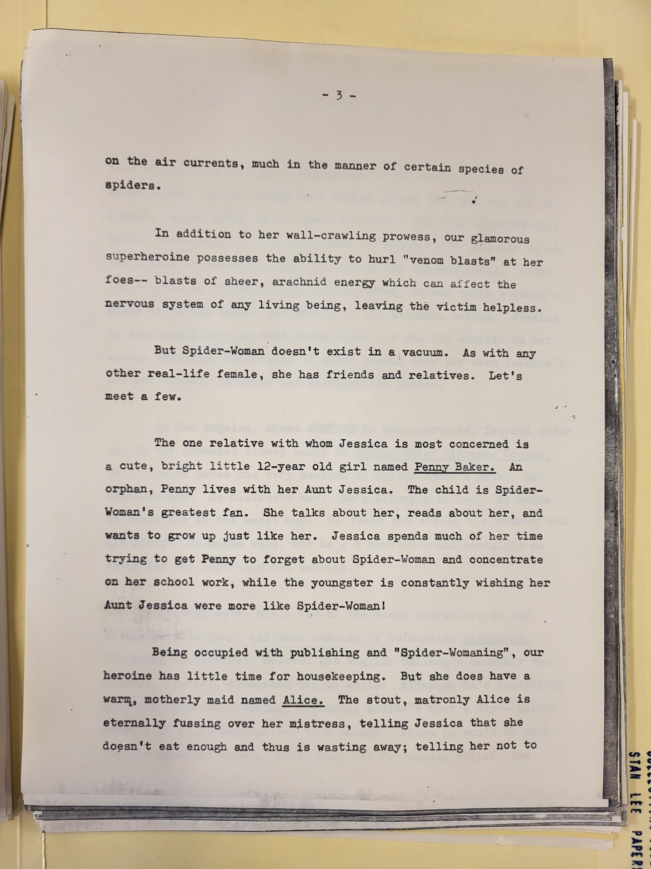

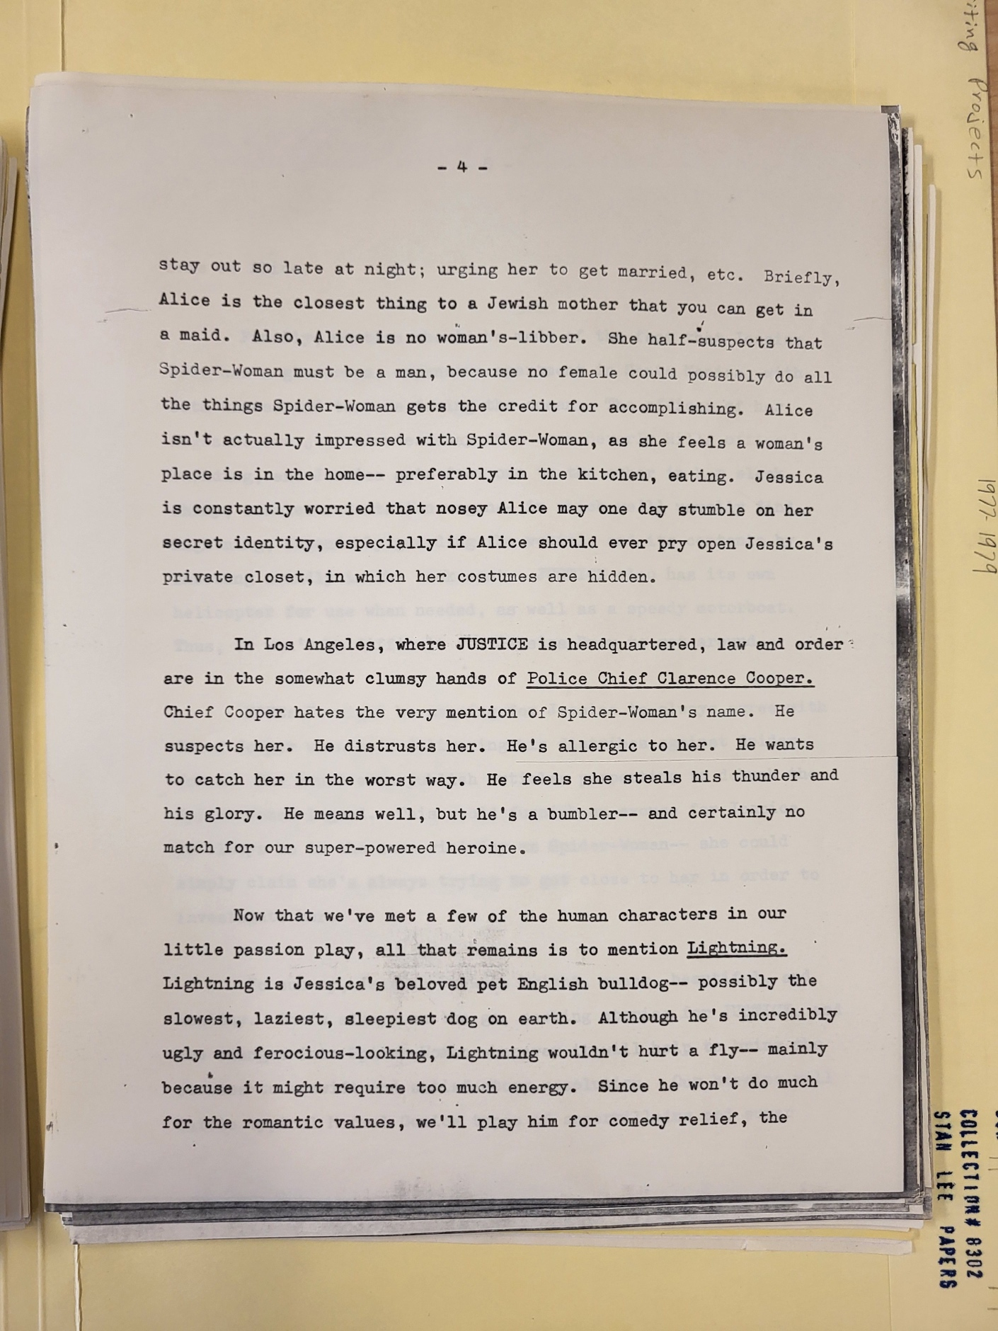

**Figure 2.** “‘The Mysterious Spider-Woman’ Series Overview,” Undated, 3-4, Box 11, Folder 14, Stan Lee Papers, Collection Number 8302, American Heritage Center, University of Wyoming.

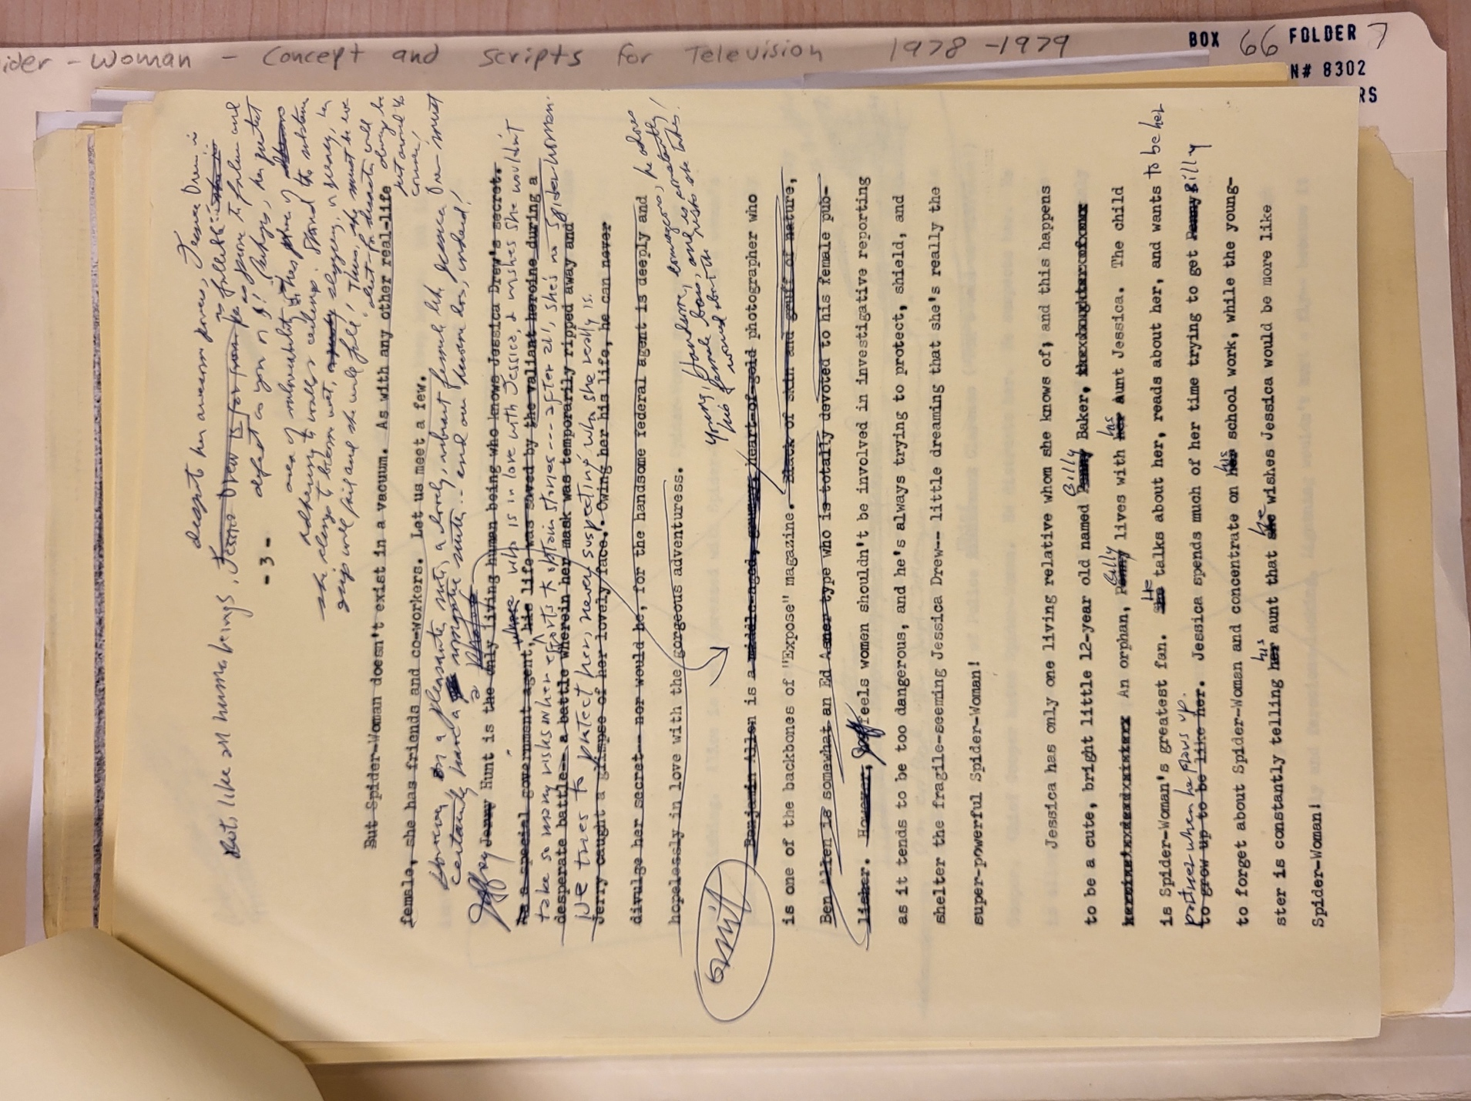

**Figure 3.** “‘The Mysterious Spider-Woman’ Revised Series Overview with Handwritten Notes,” Undated, 3, Box 66, Folder 7, Stan Lee Papers, Collection Number 8302, American Heritage Center, University of Wyoming.

**Figure 4.** “‘The Mysterious Spider-Woman’ Revised Series Overview with Handwritten Notes,” Undated, 4, Box 66, Folder 7, Stan Lee Papers, Collection Number 8302, American Heritage Center, University of Wyoming.

**Figure 5.** “‘The Mysterious Spider-Woman’ Revised Series Overview with Handwritten Notes,” Undated, 1, Box 66, Folder 7, Stan Lee Papers, Collection Number 8302, American Heritage Center, University of Wyoming.

Bibliography

Dietsch, TJ. “What You Need to Know About Marvel’s First Animated Series, ‘Spider-Woman.’” *Marvel Entertainment* (blog), November 14, 2019. https://www.marvel.com/articles/tv-shows/spider-woman-series-disney-plus-watch-now.

“Directory of TV Programmers, Distributors & Services,” Television/Radio Age, 28, no. 14 (March 9, 1981).

Grossman, Gary H. *Saturday Morning TV*. New York: Dell Pub. Co, 1981.

Lee, Stan. “The Brute-Man Cometh! A Senses-Staggering Suggestion for Making the SPIDER-WOMAN Show More Appealing to Male Viewers.,” December 18, 1979. Box 66, Folder 7. Stan Lee Papers, Collection Number 8302, American Heritage Center, University of Wyoming.

———. “‘The Mysterious Spider-Woman’ — ‘The Origin of Spider-Woman’ Introductory Show,” October 1978. Box 11, Folder 14. Stan Lee Papers, Collection Number 8302, American Heritage Center, University of Wyoming.

Morning Consult, and Hollywood Reporter. “National Tracking Poll #190429, April 11-15, 2019, Crosstabulation Results,” April 2019. https://morningconsult.com/wp-content/uploads/2019/04/190429_crosstabs_HOLLYWOOD_REPORTER_Adults_v1_ML.pdf.

“Spider-Woman Characters Summary,” Undated. Box 66, Folder 7. Stan Lee Papers, Collection Number 8302, American Heritage Center, University of Wyoming.

Terrace, Vincent. *Television, 1970-1980*. 1st ed. San Diego : London: A.S. Barnes ; Tantivy Press, 1981.

“‘The Mysterious Spider-Woman’ Revised Series Overview with Handwritten Notes,” Undated. Box 66, Folder 7. Stan Lee Papers, Collection Number 8302, American Heritage Center, University of Wyoming.

“‘The Mysterious Spider-Woman’ Series Overview,” Undated. Box 11, Folder 14. Stan Lee Papers, Collection Number 8302, American Heritage Center, University of Wyoming.

1. Gary H. Grossman, *Saturday Morning TV* (New York: Dell Pub. Co, 1981), 409; “Directory of TV Programmers, Distributors & Services,” Television/Radio Age, 28, no. 14 (March 9, 1981): A-6; Vincent Terrace, *Television, 1970-1980*, 1st ed (San Diego : London: A.S. Barnes ; Tantivy Press, 1981), 187; TJ Dietsch, “What You Need to Know About Marvel’s First Animated Series, ‘Spider-Woman,’” *Marvel Entertainment* (blog), November 14, 2019, https://www.marvel.com/articles/tv-shows/spider-woman-series-disney-plus-watch-now.
2. “Spider-Woman Characters Summary,” Undated, Box 66, Folder 7, Stan Lee Papers, Collection Number 8302, American Heritage Center, University of Wyoming; Stan Lee, “‘The Mysterious Spider-Woman’ — ‘The Origin of Spider-Woman’ Introductory Show,” October 1978, Box 11, Folder 14, Stan Lee Papers, Collection Number 8302, American Heritage Center, University of Wyoming.
3. “‘The Mysterious Spider-Woman’ Series Overview,” Undated, Box 11, Folder 14, Stan Lee Papers, Collection Number 8302, American Heritage Center, University of Wyoming.
4. “‘The Mysterious Spider-Woman’ Revised Series Overview with Handwritten Notes,” Undated, Box 66, Folder 7, Stan Lee Papers, Collection Number 8302, American Heritage Center, University of Wyoming.
5. Stan Lee, “The Brute-Man Cometh! A Senses-Staggering Suggestion for Making the SPIDER-WOMAN Show More Appealing to Male Viewers.,” December 18, 1979, Box 66, Folder 7, Stan Lee Papers, Collection Number 8302, American Heritage Center, University of Wyoming.
6. Morning Consult and Hollywood Reporter, “National Tracking Poll #190429, April 11-15, 2019, Crosstabulation Results,” April 2019, https://morningconsult.com/wp-content/uploads/2019/04/190429_crosstabs_HOLLYWOOD_REPORTER_Adults_v1_ML.pdf.